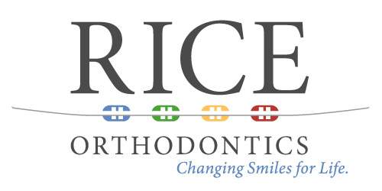

Routine Dental Cleaning
Certificate

I, Dr. ____________________________ certify that

________________________________ has been in our office today
(patient)
for their routine dental cleaning. My patient thus qualifies for five

“tokens”, to be awarded at Dr. Rice's office on submission of this form.

_________________________________
Dentist Signature

_________________________________
Date

*The purpose of our Cooperation Rewards Program is for our younger patients to take “ownership” in the investment of orthodontic treatment that their parents have provided for them. As an incentive for our patients to have routine dental cleanings with you and also by them displaying good oral hygiene throughout treatment, we will reward them with our tooth tokens that they may cash in for prizes during orthodontic treatment. Our hope is that this behavioral modification incentive program will help our mutual patients to have clean, healthy, and spot free teeth upon completion of their orthodontic treatment. As always, we recommend that our mutual patients who are in active orthodontic treatment visit you to have at least 2 routine dental cleanings a year to insure healthy gums and teeth – If needed please recommend a 3 cleanings at your discretion.

Thank you for your cooperation in helping our mutual patient achieve the smile that they have always wanted!

Shawn Rice, DMD, MS and Ortho Team!

